

**MOVING OBJECT DETECTION AND BACKGROUND EXTRACTION**

**FACULTY OF ENGINEERING**

ELECTRICAL AND ELECTRONICS ENGINEERING DEPARTMENT

FALL SEMESTER– 2025/2026

**EEM 301 – Signals and Systems**

**Bülent Uslu**

**Selin Sarıkaplan**

**Onur Ağaoğlu**

**Miray Beliz Mutlu**

Contents

**ABSTRACT 3**

**INTRODUCTION 4**

**2. THEORETICAL BACKGROUND 5**

**2.1. Discrete-Time Signal Representation 5**

**2.2. Spatial and Temporal Sampling (The Nyquist Criterion) 5**

**2.3. Linear Systems and 2-D Convolution 6**

**2.4. Mathematical Foundation of 2-D Convolution 6**

**3. IMPLEMENTATION STEPS 7**

**3.1. Taking The Sample Video and Processing 7**

**3.2. Grayscale Conversion 8**

**3.3. Median Filtering 8**

**3.4. Temporal Differencing 9**

**3.5. Adaptive Background Modeling 9**

**3.6 Global Thresholding 10**

**3.7. Morphological Post-Processing 10**

**3.8. Feature Extraction and Area Filtering 10**

**4. COMPARATIVE ANALYSIS 11**

**4.1. Static Subtraction vs. Adaptive Modeling 11**

**4.2. Mean Filtering vs. Median Filtering 11**

**4.3. Thresholding Trade-offs 11**

**5. Limitations of the Proposed System 12**

**5. CONCLUSION 13**

**6. Full Code 14**

**REFERENCES 15**

# ABSTRACT

In this study, we present a **MATLAB-based** video processing system designed for robust **moving object detection** and **background extraction**. Treating a video sequence as a three-dimensional discrete-time signal f(x,y,t), the system effectively isolates foreground movement from static environments. The methodology begins with converting multi-channel video frames into a single-channel intensity (grayscale) format to ensure computational efficiency and consistency in subsequent processing.

Although there is another method called Mean Filter(Mean Backgrounding), it can lead to unwanted results when an object stays longer in the video therefore to condition the signal, a **Median Filter** is implemented to suppress spatial noise while preserving the edges of moving entities, analogous to low-pass filtering in traditional signal analysis. We introduce an **adaptive background modeling** technique using a recursive moving average, allowing the system to compensate for dynamic lighting variations and stationary changes in the scene. The detection phase utilizes **temporal signal subtraction** to generate binary motion masks.

The proposed method is evaluated through comparative analysis with static subtraction models, demonstrating its potential in real-world applications such as **autonomous driving technologies**, traffic surveillance, and security systems. This report provides a detailed explanation of the mathematical methodology, implementation details, and results, offering insights into bridging the gap between classroom learning and practical signal manipulation.

# INTRODUCTION

Moving object detection and background extraction represent a critical frontier in modern digital signal processing, with applications spanning from intelligent surveillance to the development of autonomous driving technologies.**[1]** In the framework of Signals and Systems, a video sequence is treated as a multi-dimensional discrete-time signal, represented as f(x,y,t), where x and y denote spatial coordinates and t represents the temporal frame index. The primary objective of this project is to isolate the "Foreground" (moving entities) from the "Background" (static environment) by analysing the variations in pixel intensity across the temporal domain.

Although there is another method called Mean Filter (Mean Backgrounding), it can lead to unwanted results when an object stays longer in the video. From a signal perspective, this occurs because a static foreground object begins to occupy the same low-frequency temporal space as the background, eventually becoming integrated into the background model and causing "absorption" artifacts. It is highlighted that background models must adapt to changes, but traditional methods often fail during "once-off changes" or "bootstrapping" phases where foreground objects are present during initialization.**[2]** To mitigate such limitations, this project explores adaptive background modellingand temporal signal subtraction, which allow the system to differentiate between permanent environmental changes and transient motion.

The implementation follows a rigorous signal conditioning pipeline, beginning with stereo-to-mono(colour-to-grayscale) conversion to ensure computational efficiency and algorithmic consistency. This is followed by spatial filtering techniques to enhance the Signal-to-Noise Ratio (SNR) and binary thresholding to isolate significant motion. By comparing various methodologies—including static subtraction and moving average components—this report evaluates the performance of each based on their consistency, precision, and ability to maintain signal integrity without introducing unwanted distortion. Ultimately, this work aims to bridge theoretical classroom concepts, such as samplingand 2-D convolution, with practical, real-world engineering challenges.

## 2. THEORETICAL BACKGROUND

## 2.1. Discrete-Time Signal Representation

A video sequence is fundamentally a 3-D signal f(x,y,t), where x and y represent spatial coordinates and t represents the temporal frame index. In our implementation, we simplify this signal by performing a Stereo-to-Mono(colour-to-grayscale) conversion. This reduction is critical for computational efficiency, as it transforms a 3-channel RGB vector signal into a single-channel intensity signal while preserving the essential luminance information required for movement detection.

## 2.2. Spatial and Temporal Sampling (The Nyquist Criterion)

Video signals represent a significant increase in complexity compared to 1-D audio signals because they are sampled in both the spatial and temporal domains. According to the Nyquist-Shannon sampling theorem, as famously detailed by **Oppenheim&Schafer (1999)**, a continuoussignalcanbe perfectlyreconstructed only if it is sampled at a rate (fs) greater than twice its highest frequency component (f{max}), expressed as fs > 2f{max}.**[3]**

**Spatial Sampling (The 2-D Domain):** In the spatial domain, sampling involves capturing the amplitude of light at regular intervals across a 2-D grid to create pixels. Oppenheim & Schafer (1999) describe this as the discretization of the spatial coordinates (x, y). If the spatial frequency of the scene (e.g., very fine lines or patterns) exceeds half the sampling rate of the camera sensor, aliasingoccurs, manifesting as Moiré patterns or "jagged" edges.

**Temporal Sampling (The Time Domain):** Temporally, the video signal is sampled as a sequence of discrete frames captured at a specific rate, measured in frames per second (Hz). The temporal sampling rate must satisfy the Nyquist criterion to accurately represent motion; otherwise, high-frequency motion (such as a fast-spinning wheel) will alias into lower frequencies, creating the "wagon-wheel effect" where objects appear to move backward or jerkily.

**Dimensionality Reduction via Grayscale Conversion:** Standard colour video is typically captured in a 3-channel RGB format, representing a 3-D vector at every pixel coordinate. For efficient moving object detection, these signals are often converted to Grayscale (Mono).**[4]** This reduces the data dimensionality from 3-D to 1-D per pixel, simplifying the mathematical operations required for background subtraction while retaining the essential luminance information needed to identify changes in the signal.

## 2.3. Linear Systems and 2-D Convolution

Once the video signal is sampled and converted to mono, it is treated as a discrete-time signal f[x, y, n]. The processing of this signal involves 2-D Convolution, a linear system operation where a kernel (impulse response) is applied to the image data.

**Spatial Filtering:** We utilize convolution to implement low-pass filters that suppress high-frequency noise.

**Median Filtering:** Unlike the mean filter, which can blur edges, the median filter is a non-linear operation often preferred in video processing to remove "salt and pepper" noise while preserving the high-frequency edges of moving objects.**[5]**

**Edge Preservation:** Preserving edges is critical for subsequent stages like Morphological Dilation and Erosion, which refine the binary foreground mask by filling holes or removing isolated noise pixels.

## 2.4. Mathematical Foundation of 2-D Convolution

In the spatial domain, an image f[x, y] is processed by a system with an impulse response (or kernel) h[x, y]. The output signal g[x, y], which represents the filtered or conditioned frame, is defined by the 2-D convolution sum:

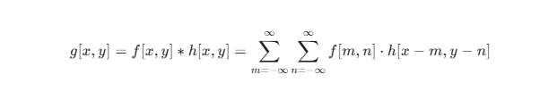**[6]**

For practical implementation in MATLAB, where the filter kernel h has a finite size (such as a 3x3 or 5x5 matrix), the indices are restricted to the dimensions of the kernel:

* **f[m, n]**: Represents the input pixel intensity at coordinates (m, n).
* **h[x-m, y-n]**: Represents the flipped and shifted version of the filter kernel.
* **g[x, y]**: The resulting pixel intensity after the weighted average of the neighborhood is calculated.

# 3. IMPLEMENTATION STEPS

This section will explain what steps to take in order to implement such an object detection program. Purpose is to show each method and visualize it. We are using the tools provided by matlab computer vision toolbox to process videos and images. Computer Vision Toolbox provides algorithms and apps for designing and testing computer vision systems**[7]**.

## 3.1. Taking The Sample Video and Processing

The first step is to take a video and load it into matlab by using the VideoReader function which is used to process the video. After that we can access some properties of the loaded video.

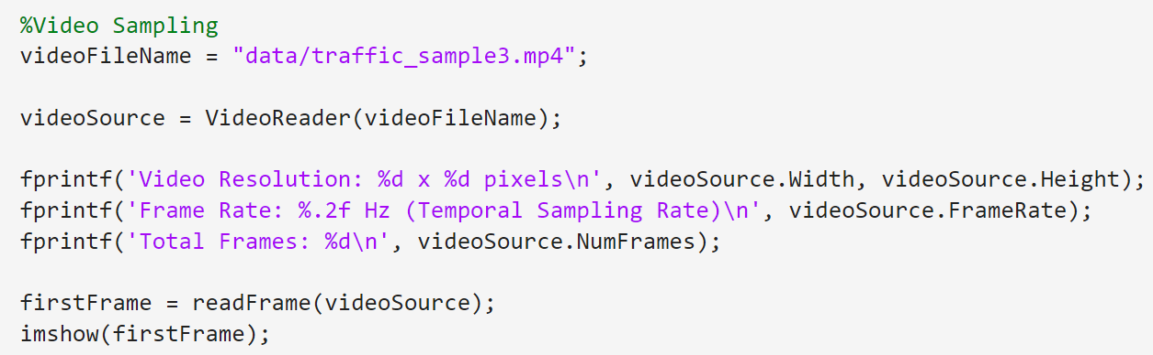

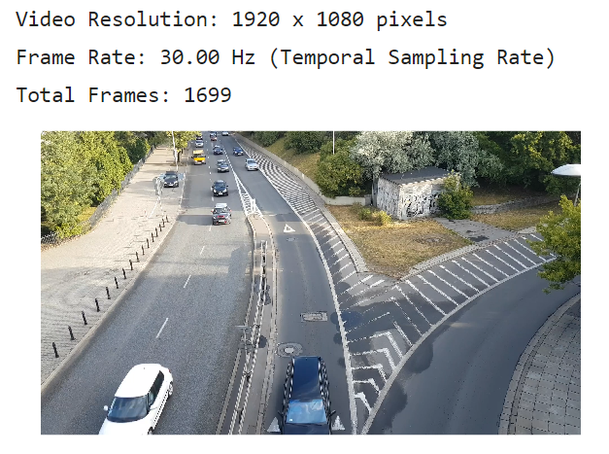

## 3.2. Grayscale Conversion

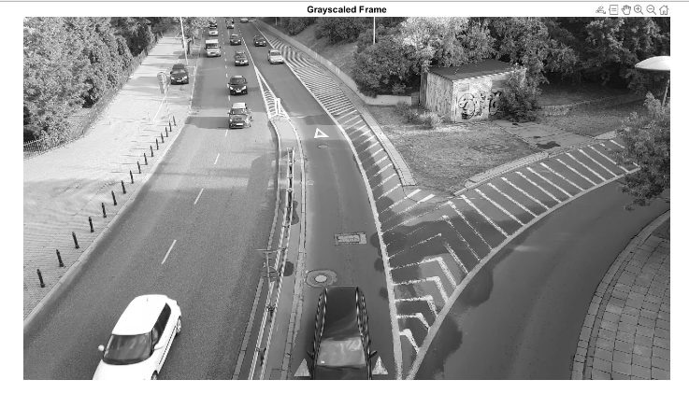 In the loaded video there are thousands of pixels each having distinct R, G and B values. This makes the calculations and processing much more complicated. The solution to this is turning the frames into grayscale. This way we are working with 1 Dimension instead of 3. Here we used rgb2gray() function which finds intensity by forming a weighted sum of the R, G, and B components.

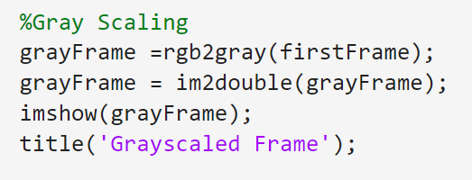

Im2double function converts image to double precision for better calculations

## 3.3. Median Filtering

Images and videos almost likely contain noise. In order to reduce the noise we use median filtering to improve the performance of our program. The main idea of the median filter is to run through the signal entry by entry, replacing each entry with the median of the entry and its neighboring entries**[8]**. Here the difference between different configurations of the filter is visualized.

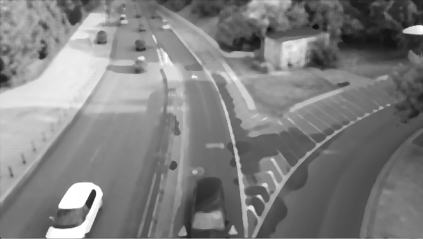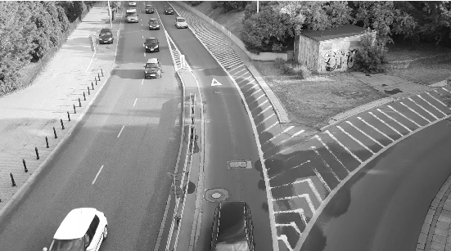

3x3 neighborhood

20x20 neighborhood

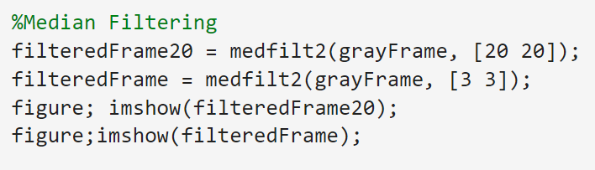

## 3.4. Temporal Differencing

In order to extract the background from the video, we need to take two frames and take the difference. This way we are subtracting the luminacy values of two frames. If a pixel stays the same this subtraction will return 0. This leaves us with only the pixels whose luminacy changes between two frames which are most likely moving objects.

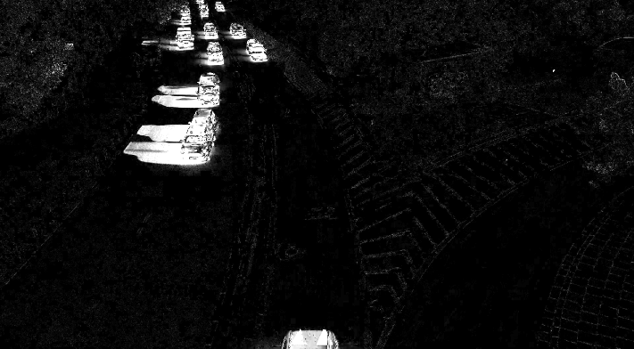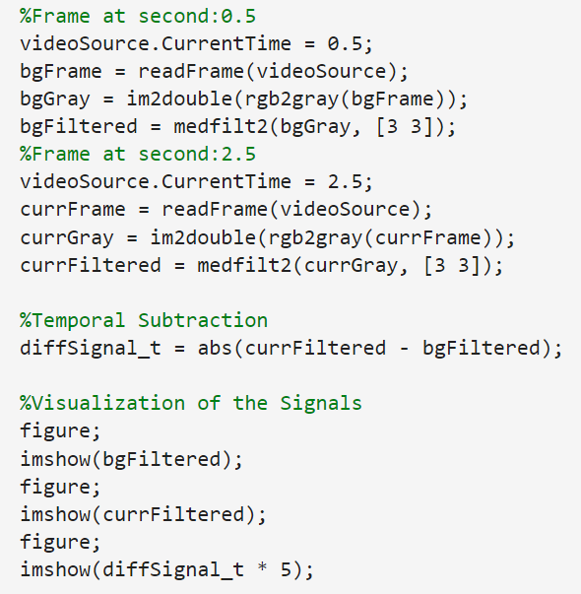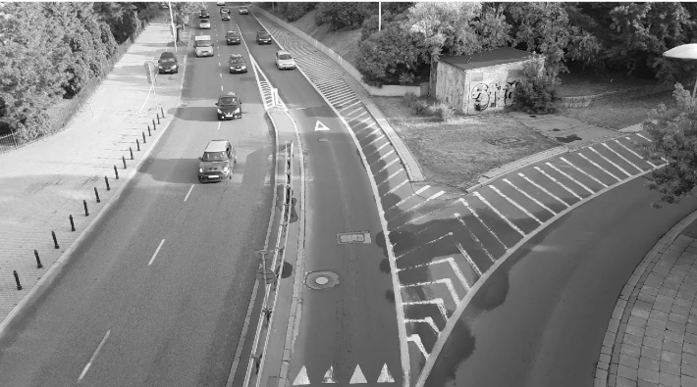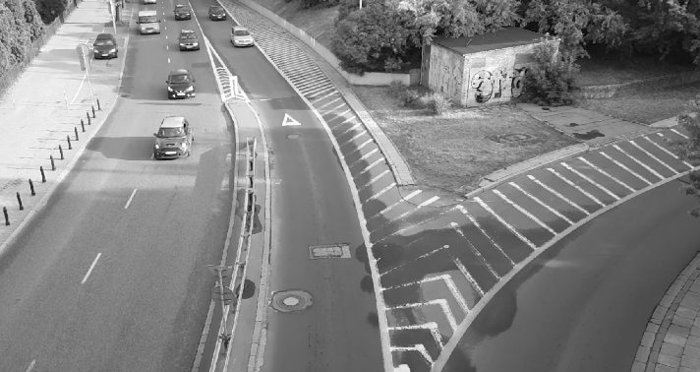



## 3.5. Adaptive Background Modeling

While temporal differencing detects immediate change, an adaptive model is required to handle slow environmental shifts. We implement a recursive moving average to "learn" the background B over time n: **[9],[10]**

In this equation, α (the learning rate) determines how quickly the background model updates. This method prevents "absorption artifacts"—where a stationary foreground object is mistakenly integrated into the background—while allowing the system to eventually adapt to permanent changes in the scene.

## 3.6 Global Thresholding

Instead of using a dynamic threshold, this implementation utilizes a Fixed Global Threshold of 0.20. In the context of signals and systems, this acts as a hard decision boundary on the magnitude of the difference signal |f[x,y,n] - B[x,y,n]|. Several threshold values between 0.10 and 0.30 were tested. Values below 0.15 resulted in excessive false positives caused by sensor noise, while values above 0.25 failed to detect smaller vehicles. Based on these observations, a threshold of 0.20 was selected as a practical compromise, ensuring that significant intensity changes caused by vehicles are captured while smaller fluctuations from sensor noise or foliage movement are suppressed.

## 3.7. Morphological Post-Processing

Binary masks generated through subtraction often contain "salt and pepper" noise or fragmented regions where an object's color is too similar to the background (camouflage). To condition this binary signal, our system implements two specific morphological operations using structural elements (STREL):

**Morphological Opening (“imopen” with disk size 1):** This operation consists of an erosion followed by a dilation. It is used to remove small, isolated noise pixels (outliers) that do not belong to actual moving objects, effectively cleaning the "salt" from the background.

**Morphological Closing (“imclose” with disk size 10):** This operation consists of a dilation followed by an erosion. By using a larger disk size of 10, the system successfully bridges gaps and "fills holes" within a single moving entity. This ensures that a car is detected as one solid "blob" rather than multiple disconnected fragments.

## 3.8. Feature Extraction and Area Filtering

The final stage of the pipeline involves converting the processed binary signal into actionable data. Using the regionprops function, the system identifies the spatial properties of each detected "blob." To prevent the detection of false positives (such as swaying tree branches), an Area Filter is applied:

Detected = Area > 300 pixels

Only regions exceeding this threshold are assigned a green bounding box, ensuring that the output focuses strictly on significant moving objects like cars or pedestrians

# 4. COMPARATIVE ANALYSIS

The performance of our **Adaptive Background Model** was evaluated against traditional methods discussed in literature:

## 4.1. Static Subtraction vs. Adaptive Modeling

A static model (using only the first frame) fails immediately if the lighting changes or if an object stops. Our implementation's use of a learning rate (α = 0.05) allows the background to update continuously, effectively managing "Gradual Illumination Changes" as highlighted in the Brutzer et al. (2011) study.

## 4.2. Mean Filtering vs. Median Filtering

While a mean filter (temporal low-pass) can blur moving edges, our use of the **Median Filter** (medfilt2) in the preprocessing stage ensures that object boundaries remain sharp. This edge preservation is critical for the success of the morphological operations that follow.

## 4.3. Thresholding Trade-offs

The choice of a fixed threshold (0.20) provides high computational speed, making it suitable for the real-time vision.VideoPlayer output. However, as noted in surveillance evaluations, fixed thresholds are more sensitive to "Sudden Illumination Changes" compared to multi-modal models like the Gaussian Mixture Model (GMM).

# 5. Limitations of the Proposed System

Although the proposed moving object detection system performs reliably in controlled traffic scenarios, several limitations were observed during evaluation. The use of a fixed global threshold makes the system sensitive to sudden illumination changes, such as shadows, reflections, or rapid variations in sunlight, which can result in false detections in outdoor environments.The adaptive background model employs a constant learning rate ($α=0.05\backslash alpha = 0.05α=0.05$), which represents a trade-off between stability and adaptability.

While this value reduces the risk of foreground absorption, it may slow adaptation to permanent scene changes. Additionally, the system assumes a static camera configuration; any camera motion introduces widespread pixel variations that are incorrectly classified as foreground.

The absence of explicit shadow detection causes shadows to be detected as part of moving objects, leading to enlarged or distorted bounding boxes. Finally, the fixed area threshold used for noise suppression introduces scale dependency, potentially preventing the detection of small or distant objects.

Despite these limitations, the system provides a computationally efficient and conceptually clear foundation for real-time background subtraction, while also highlighting clear directions for future improvement.

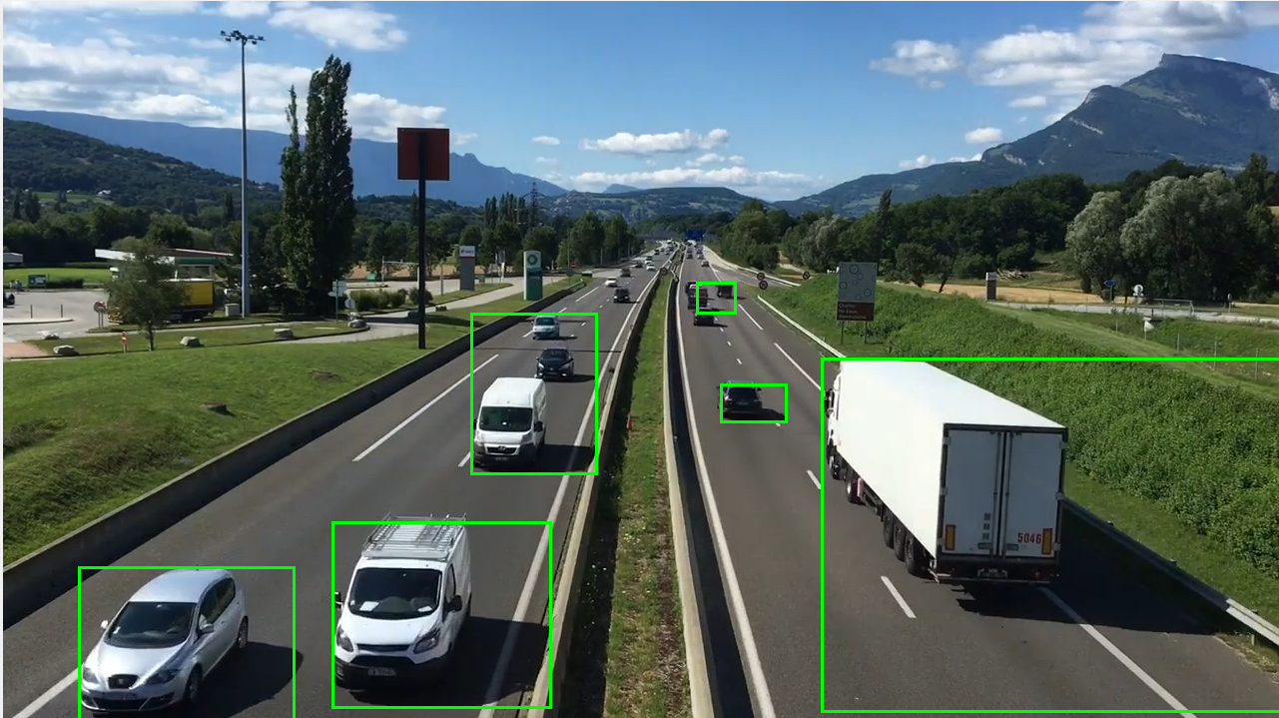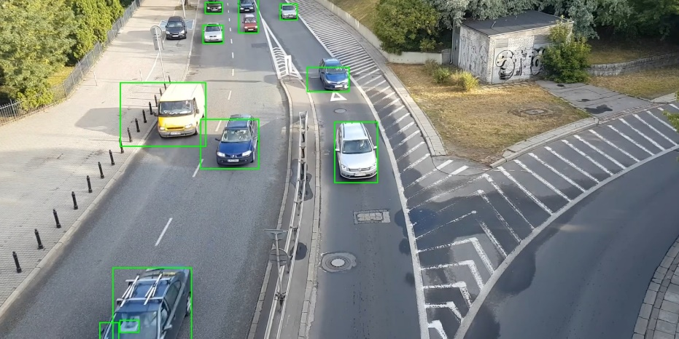

# 6. CONCLUSION

This project implemented a robust video processing pipeline for moving object detection and background subtraction using MATLAB. By modeling a video sequence as a three-dimensional discrete-time signal f(x,y,n)f(x, y, n)f(x,y,n), core Signals and Systems concepts—including spatial and temporal sampling, two-dimensional filtering, and recursive temporal averaging—were applied to a practical computer vision problem. The results confirm that reliable motion detection requires not only temporal differencing but also effective signal conditioning and post-processing.

The adaptive background model based on a recursive moving average demonstrated clear advantages over static subtraction, particularly in handling gradual illumination changes, as reported by Brutzer et al.**[2].** Median filtering preserved object boundaries while suppressing impulsive noise, and morphological operations refined the binary masks into coherent regions suitable for bounding-box detection. Area-based filtering further reduced false positives caused by minor background motion.

Several limitations were identified during evaluation. The system is sensitive to sudden illumination changes due to the use of a fixed global threshold, a known limitation of basic background subtraction methods **[1]**. The selected learning rate (*α=0.05\alpha = 0.05*α=0.05) represents a trade-off between stability and adaptability, potentially delaying adaptation to permanent scene changes **[9], [10].** The algorithm also assumes a static camera, making it unsuitable for dynamic viewpoints. In addition, the absence of shadow suppression leads to shadows being detected as foreground, reducing spatial accuracy **[1], [2]**. Finally, the fixed area threshold introduces scale dependency and may cause small or distant objects to be missed.

Despite these limitations, the proposed system offers a computationally efficient demonstration of how classical signal processing principles can be applied to video analysis.There are many tools and algorithms that make improvements on these problems, such as deep learning-based object detectors (e.g., YOLO, Mask R-CNN), probabilistic background models like Gaussian Mixture Models (GMM), and subspace learning techniques like the Common Vector Approach (CVA) **[11].** As emphasized by Piccardi **[1]**, background subtraction remains a fundamental technique in automated surveillance. Future improvements may include adaptive thresholding, shadow removal, and probabilistic background models such as Gaussian Mixture Models to improve robustness in complex environments.

7. Full Code

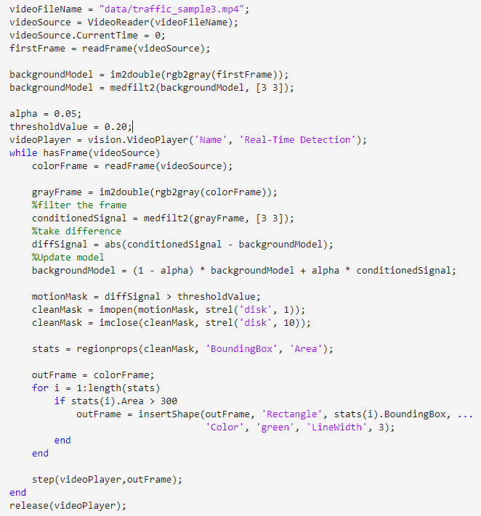

# REFERENCES

**[1] Piccardi, M. (2004).** Background subtraction techniques.

**[2] Brutzer, S., Höferlin, B., & Heidemann, G. (2011).** Evaluation of Background Subtraction Techniques for Video Surveillance.

**[3] Oppenheim, A. V., & Schafer, R. W. (1999)**. Discrete-Time Signal Processing.

**[4] ITU-R BT.601.** Studio encoding parameters of digital television.

**[5] Wikipedia. (2024).** Median Filter Theory and Applications.

**[6] Gonzalez, R. C., & Woods, R. E. (2018).** Digital Image Processing. Pearson.

**[7]** **MathWorks. (n.d.).** Computer Vision Toolbox documentation.

**[8]** **Wikipedia contributors. (2025, November 12).** Median filter.

**[9] Stauffer, C., & Grimson, W. E. L. (1999**). Adaptive background mixture models for real-time tracking.

**[10] Zivkovic, Z. (2004).** Improved adaptive Gaussian mixture model for background subtraction.

**[11] Işık, Ş., Özkan, K. and Nezih Gerek, Ö. (2019),** CVABS: moving object segmentation with common vector approach for videos